|  |
| --- |
| CGH Games, a Division of cgh Technologies, inc. |
| Slot Machine |
| **A Python Slot Machine Using Tkinter** |
| Version #3  All work Copyright © 2013 by CGH Games.  All rights reserved. |
| **By Clay Holmes** |
|  |



|  |
| --- |
| June 7th 2013 |

**Table of Contents**

1. Version History
2. Game Overview
3. Gameplay Mechanics
4. Controls
5. Interface Sketch
6. Game Progression
7. Art/Multimedia Index
8. Design Notes
9. Future Features

**Version History**

Version 0 - Tom’s Source Code to understand the workings of the slot machine code

Version 1 - A basic markup GUI using Tkinter to create buttons and a viewing area where the slot machine would go

Version 2 – Updated GUI using Tkinter that added some testing to the buttons and linked to the original slot machine source code with an import statement and calls a on the Reels() function from slotmachine_0_1.py and displays in a print statement what the result is

Version 3 – Updated GUI with the background image and tried to get button functionality working to no avail

1. **Game Overview**

*This is a GUI-based version of Tom Tsiliopoulos’s text-based slot machine game. The player is given a set amount of money to start off with, the Jackpot is set to a pre-defined amount, and the player can choose his/her bet amount and spin the reels to see what results pop up. If the reels match a winning combination, the player wins the corresponding amount, which is added to the player’s money. If a Jackpot is won, then the Jackpot is added onto the player’s money amount and reset. If the player fails to win any money or loses it all betting, the game will terminate.*

1. **Game Play Mechanics**

*Once the game loads, the player clicks the ‘Start’ button to begin play. The player’s pocket money is started out as $1000 and the Jackpot is set to $500. The player is given an option to bet money using four buttons which will set the bet at $50, $100, $500, or $1000, depending on which one is selected. The player then presses the ‘Spin’ button to spin the reels.*

*The reels will display a random set of three outputs, each with their own win/lose values:*

*Three ‘Grapes’ will multiply the Bet amount by 20*

*Three ‘Bananas’ will multiply the Bet amount by 30*

*Three ‘Oranges’ will multiply the Bet amount by 40*

*Three ‘Cherries’ will multiply the Bet amount by 100*

*Three ‘Bars’ will multiply the Bet amount by 200*

*Three ‘Bells’ will multiply the Bet amount by 300*

*Three ‘Sevens’ will multiply the Bet amount by 1000*

*Two ‘Grapes’ will multiply the Bet amount by 2*

*Two ‘Bananas’ will multiply the Bet amount by 2*

*Two ‘Oranges’ will multiply the Bet amount by 3*

*Two ‘Cherries’ will multiply the Bet amount by 4*

*Two ‘Bars’ will multiply the Bet amount by 5*

*Two ‘Bells’ will multiply the Bet amount by 10*

*Two ‘Sevens’ will multiply the Bet amount by 20*

*And one ‘Seven’ will multiply the Bet amount by 10*

*The winning of the Jackpot is random but the odds are quite low to winning the Jackpot. Fell lucky if you do win it! 15% of the player bet gets added to the Jackpot after each spin, so the longer you play and more you bet, the higher the Jackpot gets.*

*Once player has spun the reels enough and wished to quit or runs out of money, the player can hit the ‘Quit’ button to terminate the program.*

1. **Controls**

*The player controls the slot machine using the mouse to manipulate buttons on the screen. There are seven buttons in total. There is a button to start/reset the game, a button to quit the game, four buttons to place bets, and a button to spin the reels. When the ‘Start’ button is pressed at game load, the game initiates. The player’s money, Jackpot and bet amount can be reset also by pressing this button. The ‘Quit’ button exits the program. The bet buttons, set at $50, $100, $500, and $1000, will set the bet at the respective amount. Once the ‘Spin’ button is pressed, the reels spin using the set amount selected for the bet as the wager on what the results will be. If there is a winning combination, the player and jackpot receive money and the player can bet and spin again. If there is no winning combination, the player does not collect any money but the Jackpot still goes up. Once the player has no more money left, he/she can hit the ‘Start’ button to reset the game or ‘Quit’ to exit the program.*

1. **Interface Sketch**

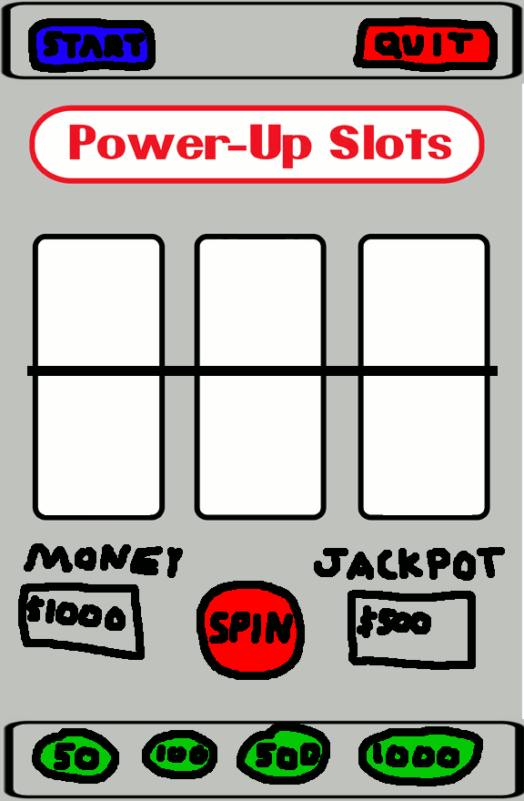

1. **Game Progression**

*The game continues as the player places bets and spins the reels. If the player gets a winning combination, that amount of money is added to the player’s money and betting can continue. The jackpot will increase with each spin until it is won or the player resets/quits the game. There is a small chance that the jackpot can be won, and if it is, it is added to the player’s money and will be added to at the next spin. If the player runs out of money, the game is over and must be reset or exited.*

1. **Art / Multimedia Index**

*8bit.gif – Background picture used for the slotmachine*

1. **Design Notes**

*The game is, as it stands, incomplete. I found difficulty working with Tkinter and trying to get the buttons situated where I wanted them to be and do what I wanted them to do.*

1. **Future Features**

*I would like to make a functioning version of this game but have found working with Tkinter frustrating and confusing.*

*I plan on adding additional functionality to the game, such as the ability to see, graphically, what the result of the spin is.*

*I would also like to add in sounds for all of the functions as well as graphics for when the jackpot is won.*